# Learning Julia: It's All Fun and Games!

In this post I'm going to show you how to use Julia to build a game of Tic-Tac-Toe. Tic-Tac-Toe is traditionally played with pen and paper, by two players, on a 3x3 square grid. One player is X and the other player is O. They both take turns placing their tokens on any empty board cell. X starts the game. The winner is the player which places three in a row, either horizontally, vertically or diagonally.

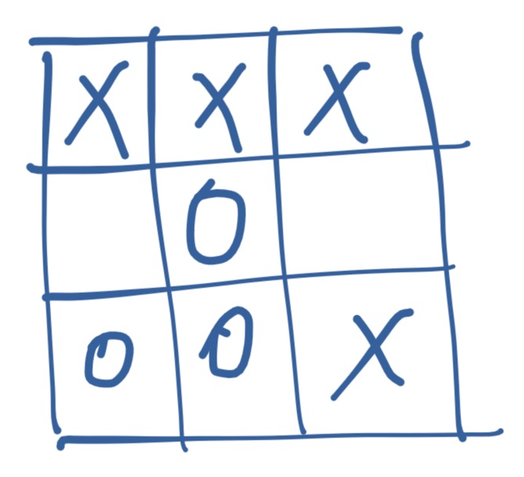

*Tic-Tac-Toe board with X winning the game (3 in a row horizontally, on the first row)*

# The Board

Let's start with the most obvious thing: the board. Julia has a perfect data structure for representing it: the Matrix. Something like:

julia> [1 2 3; 4 5 6; 7 8 9]  
3×3 Array{Int64,2}:  
 1 2 3  
 4 5 6  
 7 8 9

However, we'd like something which looks more like a proper game UI:

┌─────┬───┬───┬───┐  
│ Row │ A │ B │ C │  
├─────┼───┼───┼───┤  
│ 1 │ X │ │ O │  
├─────┼───┼───┼───┤  
│ 2 │ │ │ │  
├─────┼───┼───┼───┤  
│ 3 │ │ O │ X │  
└─────┴───┴───┴───┘

We'll define our own Board type, which will wrap a Matrix, but will use fancier rendering.

We'll use Juno as we'll work with Julia files, structured as a Project. Start by creating a folder for our game. I'm calling mine TicTacToe. Open the folder in Juno and start a Julia console. Please make sure you set the working directory to "Curent Project's Folder":

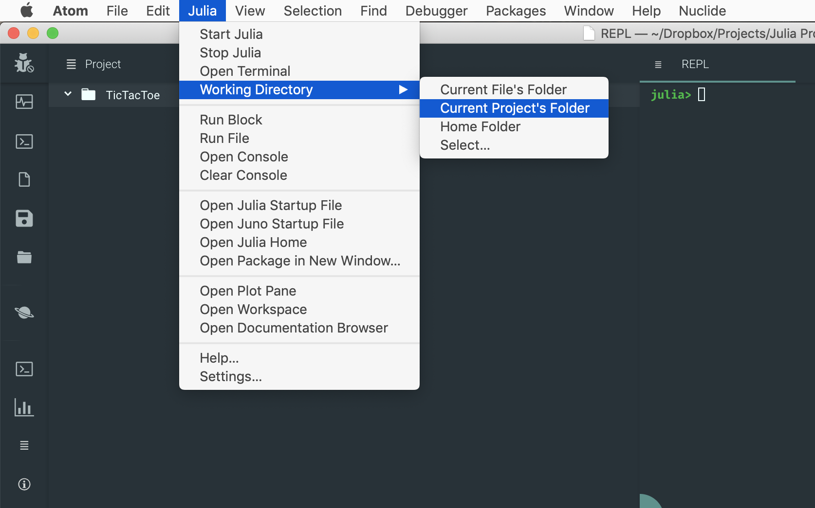

*Juno's menu and an active Julia REPL.*

Next, let's create the project structure. The best practice is to create at least two extra folders: src/ which hosts the Julia files, and test/ for the tests. With Julia:

julia> mkdir("src")  
julia> mkdir("test")

While we're at it, let's also create our main project file, TicTacToe.jl

julia> touch("src/TicTacToe.jl")

The file structure should look like this:

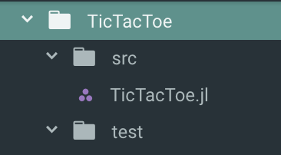

Now we can start coding. We want to define a Board type - which is made up of 9 individual Cell objects. Here's a first iteration, wrapping everything within the TicTacToe module:

# src/TicTacToe.jl  
module TicTacToe  
  
export Board, Cell  
export X, O, EMPTY  
  
const X = 'X'  
const O = 'O'  
const EMPTY = ' '  
  
struct Cell  
 value::Char  
end  
Cell() = Cell(EMPTY)  
  
struct Board  
 data::Matrix{Cell}  
end  
Board() = Board([ Cell() Cell() Cell();  
 Cell() Cell() Cell();  
 Cell() Cell() Cell()  
 ])  
  
end

We define a Cell type which wraps a Char value representing the token (X, O or empty). We also define three constants, X, O, and EMPTY which map to the corresponding chars 'X', 'O' and ' '. The space char represents an empty cell, one which is neither X nor O. It's good practice to use constants instead of values, as this does not tie our code to a fixed representation (we might want to use ❌ and ⭕️). Finally, we define a default constructor for Cell() which creates an empty cell.

As for Board, it wraps a Matrix of Cell - and has a 0 arguments Board() constructor which creates a 3x3 matrix of empty Cell objects.

#### Rendering the board

Julia provides a series of functions for rendering values on the screen. Three of the most important ones are display, show, and print, sorted from richest output to simplest. For example, for the char 'X' we have the following representations:

julia> display('X')  
'X': ASCII/Unicode U+0058 (category Lu: Letter, uppercase)  
  
julia> show('X')  
'X'  
julia> print('X')  
X

Notice how display provides the fancies output, with lengthy details. While show is much simpler, focusing on the Julian representation. Finally, print provides the simplest and most generic output, avoiding Julia specific details. We're going to overload the Base.show method, to provide pretty printing for our Board type.

For formatting we'll use a package called PrettyTables. It provides pretty printing for arrays, so we can use it to format the Board.data matrix.

We'll want to add this as a dependency for our project, so please go back to the REPL in Juno and run:

julia>] # enter Pkg mode  
(v1.1) pkg> activate .  
(TicTacToe) pkg> add PrettyTables

This adds the PrettyTables package to our project. In order make it available to our TicTacToe module we need to declare that we're using PrettyTables. I also like to automatically activate the project's environment. Please update the TicTacToe module as follows:

# src/TicTacToe.jl  
using Pkg  
pkg"activate ."  
  
module TicTacToe  
  
using PrettyTables  
  
# ... rest of the code   
  
end

We're all set now. Our show method will invoke the PrettyTables.pretty_table function. Add this at the bottom of the TicTacToe module:

# src/TicTacToe.jl  
export A, B, C  
  
const A = 'A'  
const B = 'B'  
const C = 'C'  
  
Base.show(io::IO, board::Board) = pretty_table(board.data, [A, B, C], hlines = [1,2], show_row_number = true)

The code defines a new show method for displaying Board types. It uses the pretty_table function to render the Board.data matrix, using the A, B, C labels for columns, adding horizontal lines between rows 1 and 2 and row numbers.

Now, the rendering of the Cell. Add this under the previous show declaration:

# src/TicTacToe.jl  
Base.show(io::IO, cell::Cell) = print(io, cell.value)

We're simply saying that show should reuse the same unformatted char value as print, resulting in the actual letter, no quotes or anything.

If we reload the module and create a new board, we'll see the formatting in action:

julia> include("src/TicTacToe.jl")  
julia> using .TicTacToe  
julia> board = Board()  
┌─────┬───┬───┬───┐  
│ Row │ A │ B │ C │  
├─────┼───┼───┼───┤  
│ 1 │ │ │ │  
├─────┼───┼───┼───┤  
│ 2 │ │ │ │  
├─────┼───┼───┼───┤  
│ 3 │ │ │ │  
└─────┴───┴───┴───┘

## Make your move

Now that we can render the gameboard, it's time to add the logic for placing the Xs and Os. We'll define the at function which retrieves the cell *at* a certain pair of coordinates, for example the cell at B,2 (the center of the board). We'll also add the matching at! function which will be used for setting a cell's value. The first iteration looks like this:

const labels = Dict{Char,Int}(A => 1, B => 2, C => 3)  
  
function at(board::Board, coords::Pair{Char,Int}) :: Cell  
 board.data[coords[2], labels[coords[1]]]  
end  
  
function at!(board::Board, value::Char, coords::Pair{Char,Int}) :: Board  
 cell = Cell(value)  
 board.data[coords[2], labels[coords[1]]] = cell  
 board  
end

The functions can be used for getting or, respectively, setting, the corresponding cells:

julia> at!(board, X, B=>2) # place X at column B row 2  
┌─────┬───┬───┬───┐  
│ Row │ A │ B │ C │  
├─────┼───┼───┼───┤  
│ 1 │ │ │ │  
├─────┼───┼───┼───┤  
│ 2 │ │ X │ │  
├─────┼───┼───┼───┤  
│ 3 │ │ │ │  
└─────┴───┴───┴───┘  
julia> at(board, B=>2) # get the cell at column B row 2  
X

### Always be testing

We've gone far enough with the development - time to add some tests before things get too complicated. Please create a runtests.jl file inside the test/ folder.

We can start by adding tests for creating an empty board - then setting and getting a cell:

# test/runtests.jl  
using Test  
include("../src/TicTacToe.jl")  
using .TicTacToe  
  
@testset "Board and cells" begin  
 board = Board()  
 @test at(board, A=>1).value == EMPTY # cell should be empty  
  
 at!(board, X, A=>1) # set A1 to X  
 @test at(board, A=>1).value == X # value at A1 should be X  
end

The tests can be run by simply including the file:

julia> include("test/runtests.jl")  
Test Summary: | Pass Total  
Board and cells | 2 2

Looks great, but what if somebody tries to pass an invalid value, something other than X or O?

at!(board, 'Z', A=>3) # this should fail but it doesn't  
@test at(board, A=>3).value == 'Z' # the test passes, we have a Z on our board

Our program is very gullable and happily allows illegal moves.

#### Internal constructors

In order to address this problem we need to control how new cells are created by defining an internal Cell constructor. These are special, in that all the external constructors automatically invoke the internal one. So if we define restrictions here, it will be impossible to create illegal cells. Update the Cell definition to look like this:

# src/TicTacToe.jl  
export InvalidValueException  
  
abstract type TicTacToeException <: Exception end  
  
struct InvalidValueException <: TicTacToeException  
 value::Char  
end  
  
struct Cell  
 value::Char  
  
 function Cell(v::Char)  
 in(v, [X, O, ' ']) && return new(v)  
 InvalidValueException(v) |> throw  
 end  
end

The internal constructor checks that only legal values are used - otherwise a custom InvalidValueException exception is thrown. Now the test will fail - so we need to replace it with a @test_throws type of test, to make it pass:

# test/runtests.jl  
@test_throws InvalidValueException at!(board, 'Z', A=>3) # our code correctly errors out

But what if a player will try to place her peg on top of an already taken cell? Or try to make multiple moves? We can foolproof our code by making the at and at! functions more robust:

# src/TicTacToe.jl  
export InvalidMoveException, InvalidCoordinatesException  
  
struct InvalidMoveException <: TicTacToeException  
 msg::String  
end  
  
struct InvalidCoordinatesException <: TicTacToeException  
 col::Char  
 row::Int  
end  
  
function at(board::Board, coords::Pair{Char,Int}) :: Cell  
 if ! isvalidcolumn(coords[1]) || ! isvalidrow(coords[2])  
 InvalidCoordinatesException(coords[1], coords[2]) |> throw  
 end  
  
 board.data[coords[2], labels[coords[1]]]  
end  
  
function at!(board::Board, value::Char, coords::Pair{Char,Int}) :: Board  
 cell = Cell(value)  
  
 current_value = at(board, coords)  
 isemptycell(current_value) && isvalidvalue(cell) &&   
 isvalidsequence(board, cell) ||   
 InvalidMoveException("Cell already contains a value $current_value") |> throw  
  
 board.data[coords[2], labels[coords[1]]] = cell  
 board  
end  
  
function cells(board::Board) :: Base.Generator  
 (c for c in board.data)  
end  
  
isemptycell(cell::Cell)::Bool = isempty(strip(string(cell.value)))  
isvalidcolumn(value::Char)::Bool = in(value, keys(labels))  
isvalidrow(value::Int)::Bool = 0 < value <= 3  
isvalidvalue(cell::Cell)::Bool = in(cell.value, [X, O])  
  
function isvalidsequence(board::Board, cell::Cell) :: Bool  
 isemptycell(cell) && InvalidMoveException("Can only choose X or O") |> throw  
  
 Xs = Os = 0  
 for c in cells(board)  
 if c.value == X  
 Xs += 1  
 elseif c.value == O  
 Os += 1  
 end  
 end  
  
 (Xs == Os && cell.value == X) || (Xs == Os + 1 && cell.value == O) ?  
 true :  
 throw(InvalidMoveException("Invalid move sequence $(cell.value)"))  
end

Now both at and at! perform validation on their inputs, ensuring that the coordinates are valid, the cell is empty, the passed value is legal, and the move sequence is correct. We defined a series of utility functions to perform these validations - as well as the correspoding types of exceptions.

And our updated tests:

# test/runtests.jl  
@testset "Board and cells" begin  
 board = Board()  
 @test at(board, A=>1).value == EMPTY  
  
 at!(board, X, A=>1)  
 @test at(board, A=>2).value == X  
  
 at!(board, O, A=>2)  
 @test at(board, A=>2).value == O  
  
 @test_throws InvalidValueException at!(board, 'Z', A=>3)  
  
 @test_throws InvalidCoordinatesException at(board, C=>4)  
 @test_throws InvalidCoordinatesException at!(board, O, C=>4)  
  
 @test_throws InvalidMoveException at!(board, X, A=>2)  
 @test_throws InvalidMoveException at!(board, X, A=>1)  
 @test_throws InvalidMoveException at!(board, ' ', A=>3)  
end

All tests are passing:

julia> include("test/runtests.jl")  
Test Summary: | Pass Total  
Board and cells | 9 9

## Get your game on

We've done great: our game is robust and cheaters won't stand a chance. However, two important pieces of logic are still missing: checking if a game is over (either by winning or by draw) and playing a game.

Victory is achieved by placing three of the same pegs in a **row**, **column**, or **diagonal**. These are key concepts and it would be useful to access them through functions which return the corresponding collections of cells. Here is the code to be added to the TicTacToe module:

# src/TicTacToe.jl  
function rows(board::Board) :: Vector{Vector{Cell}}  
 result = Vector{Vector{Cell}}()  
 for x in 1:3  
 push!(result, board.data[x,:])  
 end  
  
 result  
end  
  
function columns(board::Board) :: Vector{Vector{Cell}}  
 result = Vector{Vector{Cell}}()  
 for x in 1:3  
 push!(result, board.data[:,x])  
 end  
  
 result  
end  
  
function diagonals(board::Board) :: Vector{Vector{Cell}}  
 result = Vector{Vector{Cell}}()  
 push!(result, Cell[board.data[1,1], board.data[2,2], board.data[3,3]])  
 push!(result, Cell[board.data[1,3], board.data[2,2], board.data[3,1]])  
  
 result  
end

Now we can use these to implement the final pieces:

import Base: ==  
export isover, new  
  
==(a::Cell, b::Cell) = a.value == b.value  
Base.hash(cell::Cell) = hash(cell.value)  
  
function isover(board::Board) :: NamedTuple{(:status,:winner),Tuple{Bool,Char}}  
 for c in TicTacToe.columns(board)  
 c[1] == c[2] == c[3] && c[1] != Cell(EMPTY) &&   
 return (status = true, winner = c[1].value)  
 end  
 for r in TicTacToe.rows(board)  
 r[1] == r[2] == r[3] && r[1] != Cell(EMPTY) &&   
 return (status = true, winner = r[1].value)  
 end  
 for d in TicTacToe.diagonals(board)  
 d[1] == d[2] == d[3] && d[1] != Cell(EMPTY) &&   
 return (status = true, winner = d[1].value)  
 end  
  
 isempty(filter(TicTacToe.isemptycell, board.data)) &&   
 return (status = true, winner = EMPTY)  
  
 (status = false, winner = EMPTY)  
end  
  
function new()  
 upcoming_move = X  
 board = Board()  
  
 while ! isover(board).status  
 println("Your move, $upcoming_move")  
 show(board)  
  
 move = readline() |> uppercase |> strip  
 try  
 at!(board, upcoming_move, Pair(move[1], parse(Int, move[2])))  
 upcoming_move = upcoming_move == X ? O : X  
 catch ex  
 println(ex)  
 end  
 end  
  
 println("Game over!")  
 status = isover(board)  
 if in(status.winner, [X, O])  
 println("Congratulations $(status.winner)")  
 else  
 println("Draw")  
 end  
  
 show(board)  
end

The isover function iterates over the collections of columns, rows, and diagonals and for each one checks if all the cells have the same non-empty value. If yes, we have a winner. If there's no winner, it checks if the board is full. If there are no empty cells, it's a draw. For any other case, the game is still on. In order to make cell comparison cleaner, we overloaded the == operator, making it work for cell objects.

The new function starts the main game loop, asking for alternating moves and displaying the status of the game once it's over.

Time to play!

julia> include("src/TicTacToe.jl")  
julia> using .TicTacToe  
julia> new()  
Your move, X  
┌─────┬───┬───┬───┐  
│ Row │ A │ B │ C │  
├─────┼───┼───┼───┤  
│ 1 │ │ │ │  
├─────┼───┼───┼───┤  
│ 2 │ │ │ │  
├─────┼───┼───┼───┤  
│ 3 │ │ │ │  
└─────┴───┴───┴───┘  
A1  
Your move, O  
┌─────┬───┬───┬───┐  
│ Row │ A │ B │ C │  
├─────┼───┼───┼───┤  
│ 1 │ X │ │ │  
├─────┼───┼───┼───┤  
│ 2 │ │ │ │  
├─────┼───┼───┼───┤  
│ 3 │ │ │ │  
└─────┴───┴───┴───┘  
B2  
Your move, X  
┌─────┬───┬───┬───┐  
│ Row │ A │ B │ C │  
├─────┼───┼───┼───┤  
│ 1 │ X │ │ │  
├─────┼───┼───┼───┤  
│ 2 │ │ O │ │  
├─────┼───┼───┼───┤  
│ 3 │ │ │ │  
└─────┴───┴───┴───┘

## What's next?

The full code is available at https://github.com/essenciary/TicTacToe.jl

Follow me on Twitter [@essenciary](https://twitter.com/essenciary) to be notified about the upcoming chapters in our sequel. In the second part we'll build a smart Tic-Tac-Toe agent using Julia and we'll play against it. In the third, we'll publish our game on the internet, as a web app, allowing remote users to play against our bot. And in the 4th part, we'll construct a neural network and we'll train it using adversarial reinforcement learning provided by our Tic-Tac-Toe bot. See you soon!